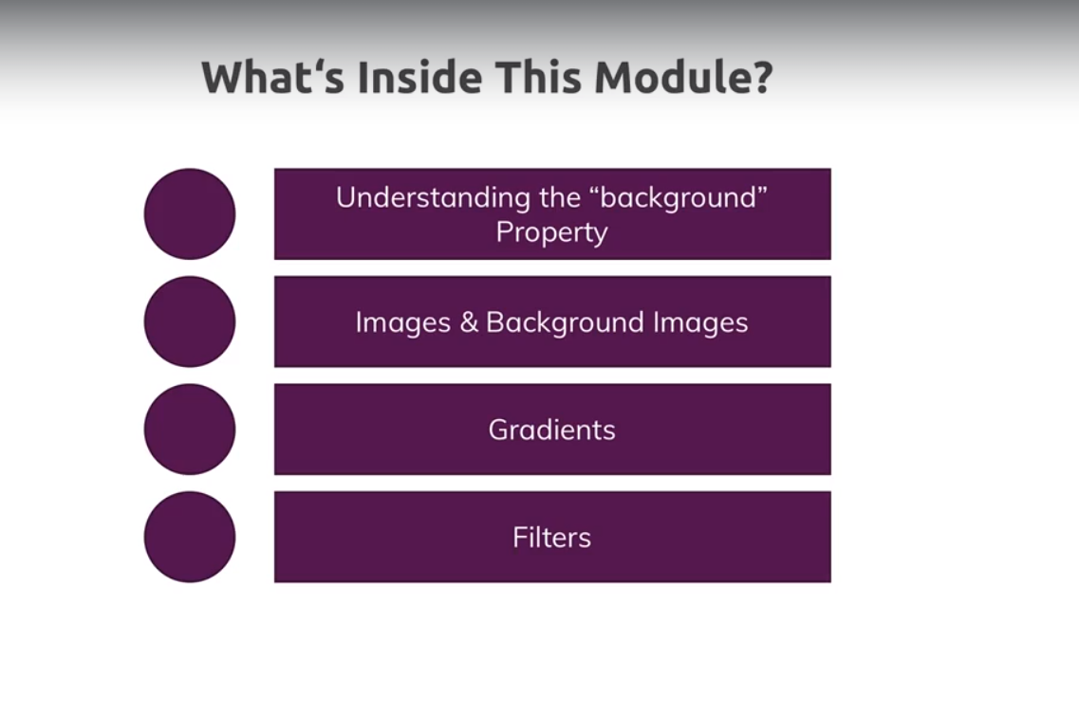

98)Background short hand property

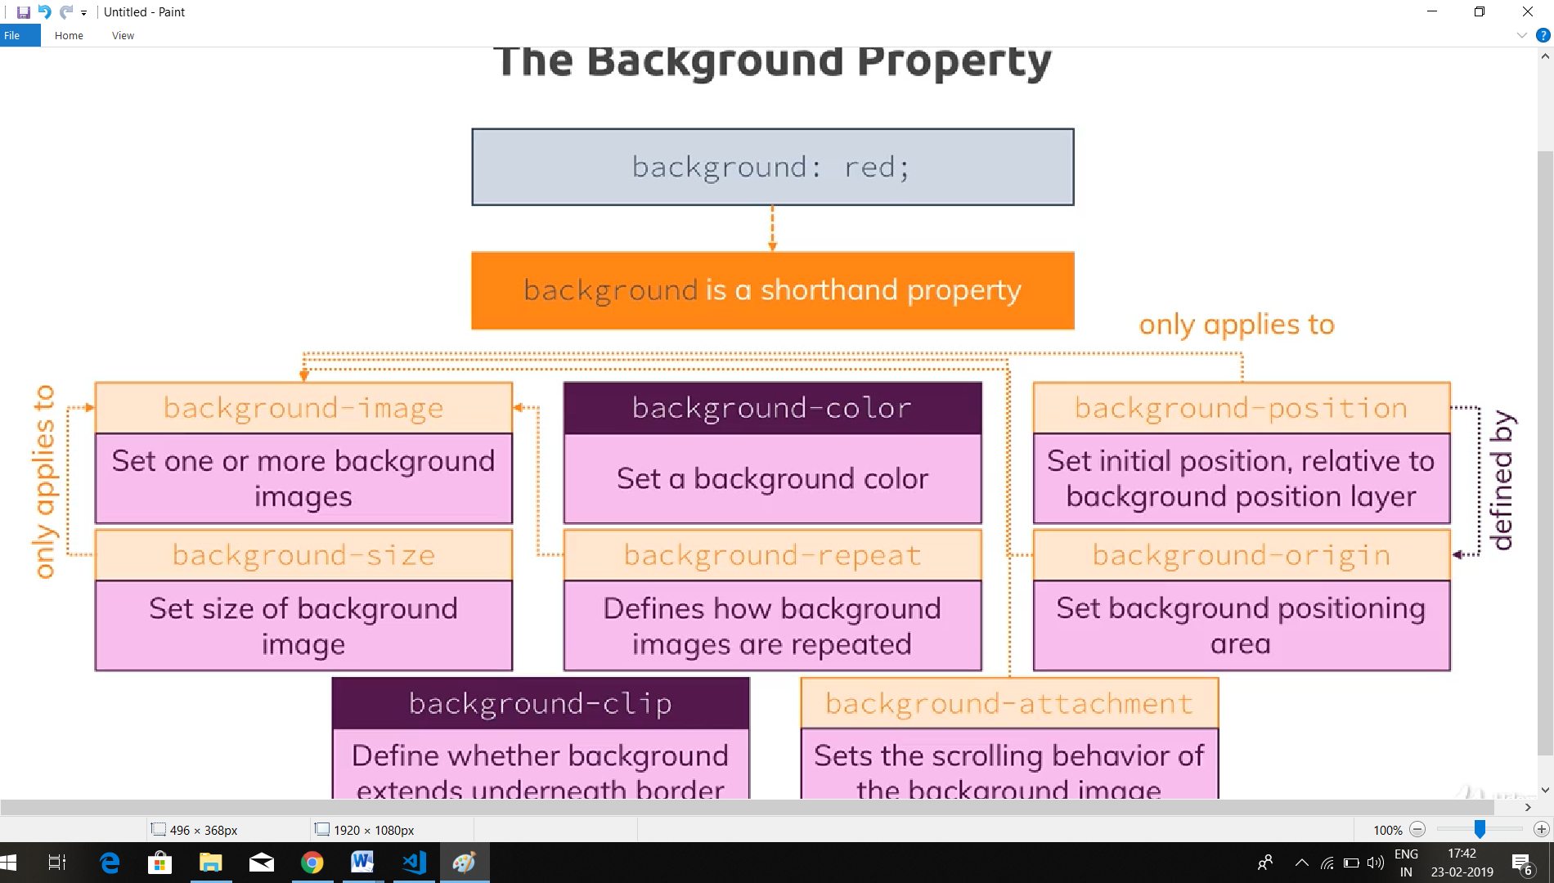

Everything oranjish refers to background-image only.

99)

Question-

1. <https://www.udemy.com/css-the-complete-guide-incl-flexbox-grid-sass/learn/v4/questions/6471710>

103)working on image layout

Questions-

1. Regarding gap at bottom in image continer

<https://www.udemy.com/css-the-complete-guide-incl-flexbox-grid-sass/learn/v4/questions/4892360>

2)regarding text align-

<https://www.udemy.com/css-the-complete-guide-incl-flexbox-grid-sass/learn/v4/questions/5561636>

3)my question-

<https://www.udemy.com/css-the-complete-guide-incl-flexbox-grid-sass/learn/v4/questions/6493868>